**Prerequisites - IBM Cloud Services**

|  |  |
| --- | --- |
| Team Id | PNT2022TMID46546 |
| Title | Hazardous Area Monitoring for Industrial Plant using IoT |

**IBM IoT Watson Platform**

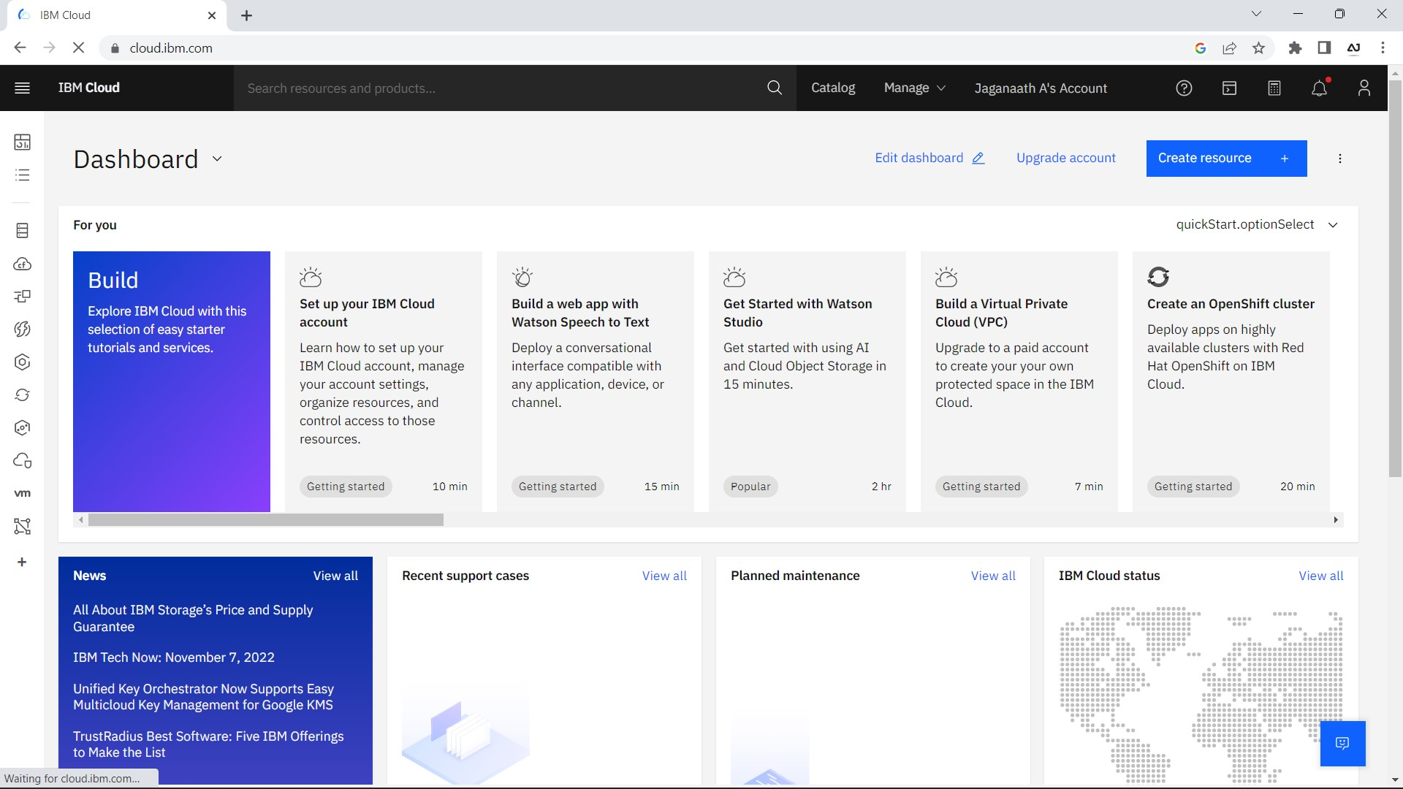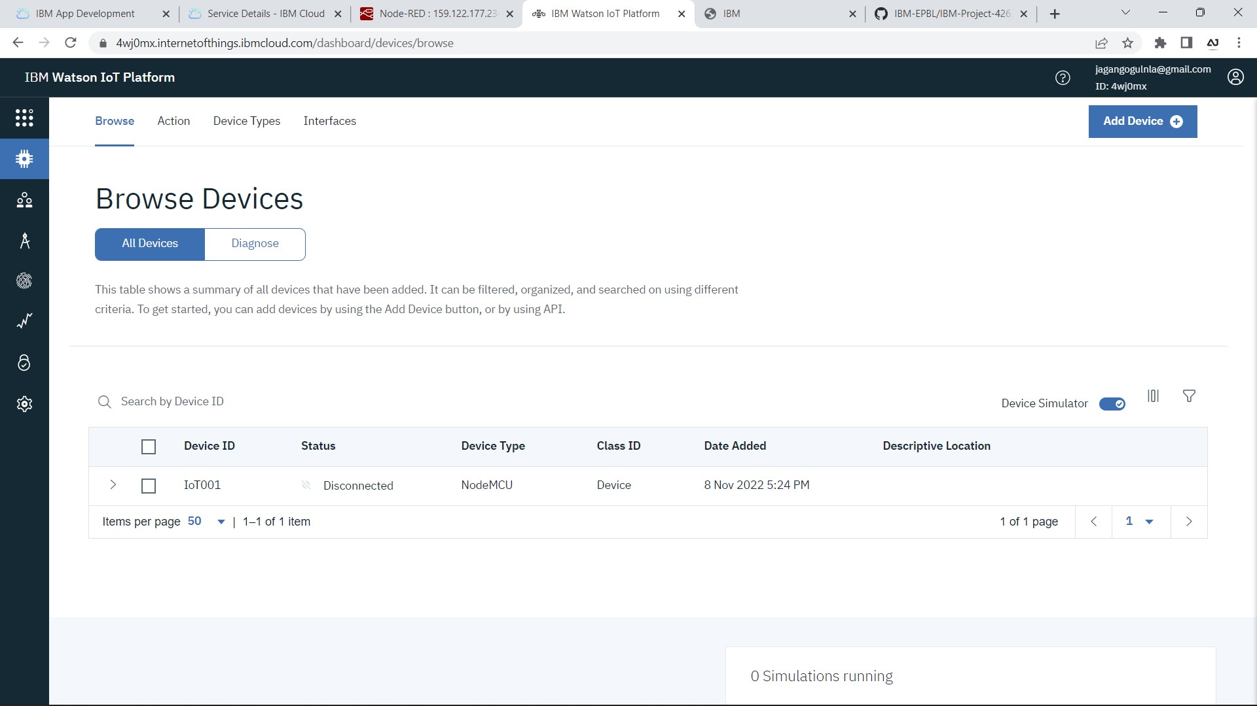

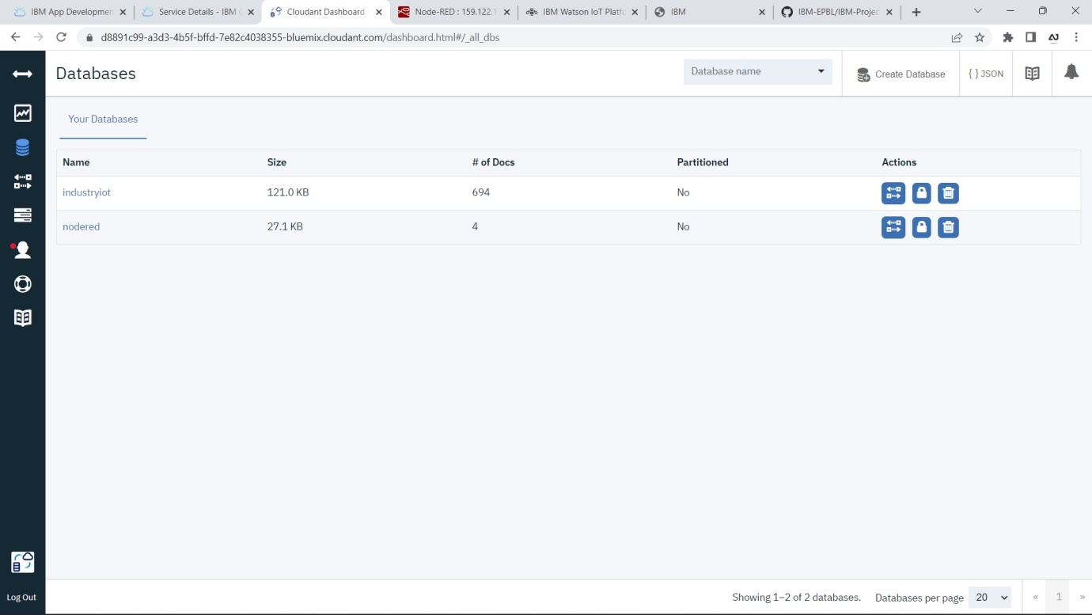**Node red Service**

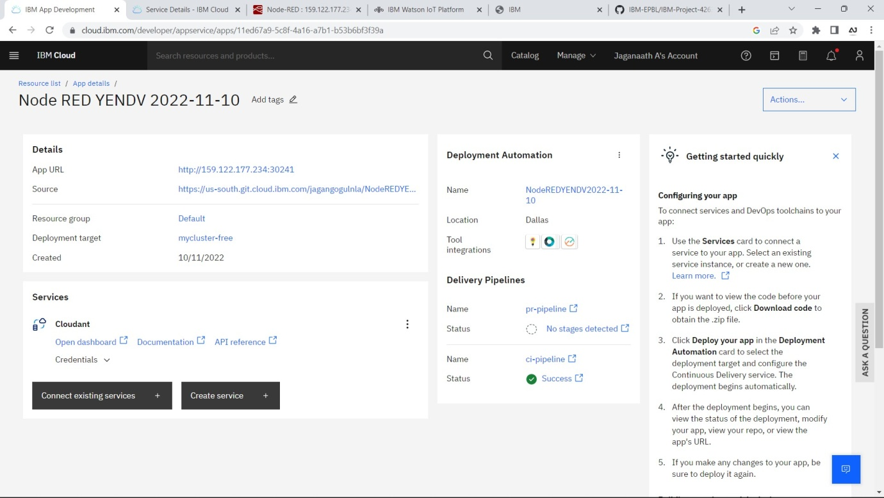

**Cloudant DB**